1. C. Señor Foods, Inc., reports the following transactions and events:
1 On January 1, 2015, it issues 2,000 shares of $100 par, 5% cumulative preferred stock, for cash of $249,000.
2 On January 10, 2015, it issues 12,000 shares of $10 par common stock, for cash of $162,000.
3 On December 1, 2015, the Board of Directors of C. Señor Foods, Inc., declares a cash dividend of $8,000 for its shareholders, to be paid on December 31, 2015.
4 On December 31, 2015, the Board of Directors pays the cash dividend which was declared on December 1, 2015.
5 On February 1, 2016, the Board of Directors declares a 2 for 1 stock split for its common shareholders, to be effective on February 28, 2016. The $10 par value of the common stock is appropriately reduced to $5.
6 On February 28, 2016, the stock split which was declared by the Board of Directors on February 1, 2016, takes effect.
7 On December 20, 2016, the Board of Directors declines to declare any cash dividend for 2016.
8 On April 1, 2017, the Board of Directors declares a cash dividend of $68,000 for its shareholders, to be paid on April 30, 2017.
9 On April 30, 2017, the Board of Directors pays the cash dividend which was declared on April 1, 2017.
10 On September 1, 2017, the Board of Directors repurchased 3,000 shares of its outstanding common stock for $15 per share.
11 On November 1, 2017, the Board of Directors re-sold 1,000 shares of the common stock it had repurchased on September 1, 2017, for $21 per share.
You may assume there are no other shares of stock outstanding, and C. Señor Foods, Inc., had sufficient retained earnings available for these transactions.
Questions:
1 Prepare any necessary journal entries for each of the chronological transactions listed above. Make sure each journal entry is complete, including any descriptions. (6 points)
2 In total (i.e., adding up 2015, 2016 and 2017), what amount of cash dividends were received by the preferred shareholders, and what amount of cashdividends were received by the common shareholders? (3 points)
SPECIFIC INSTRUCTIONS:
You must show all of your work for each question of this quiz. If you do not show your work, you will not receive any points for this quiz, even if you have the correct answer.

2. Papier Mâche Corp. uses the periodic inventory system, and implements LIFO. On March 1, it had a beginning inventory of 700 reams of paper at a cost of $11 per ream.
During the month, it made the following purchases of paper:
• March 3: 850 reams at $13 per ream
• March 12: 650 reams at $14 per ream
• March 16: 1,600 reams at $15 per ream
During the month, all of its sales were made to the Stan Still Stationery Store (which was fully paid for), as follows:
• March 4: 1,050 reams at $29 per ream
• March 14: 300 reams at $30 per ream
• March 19: 1,425 reams at $25 per ream

Questions:
1 For the month of March, what is Papier Mâche Corp.'s dollar value of cost of goods sold and ending inventory it would report on its financial statements? Round your answers to the nearest dollar. (5 points)
2 On April 1, the Stan Still Stationery Store (not Papier Mâche Corp.) sells 1,210 reams of paper at $43 per ream to its customer. Assuming it has no other inventory other than the paper purchased from Papier Mâche Corp., and it uses the average cost method, what is its cost of goods sold and gross profit it would report for this sale? Round the average cost per ream to the nearest cent. (3 points)
HINT: Every piece of information is important and relevant.

SPECIFIC INSTRUCTIONS:
You must show all of your work for each question of this quiz. If you do not show your work, you will not receive any points for this quiz, even if you have the correct answer.

3.
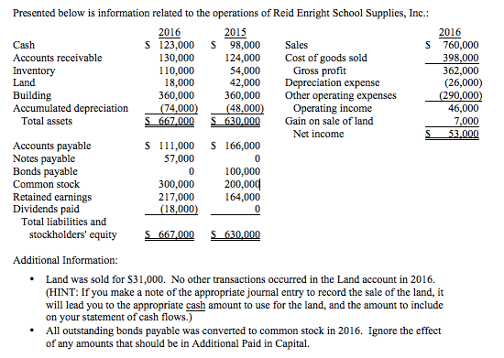
Question:
Prepare the complete statement of cash flows for Reid Enright School Supplies, Inc. in the proper format, for the year ending December 31, 2016. Use the method discussed in our lecture (i.e., indirect method).
HINT: There are 14 things (worth 0.5 points each), including any necessary title and headings, you must must properly include in order to receive full credit for this question.

4. Ilene Wreft Consulting Co. has a $200,000 balance in Accounts Receivable, and a $3,000 credit balance in Allowance for Doubtful Accounts. Credit sales for the period totaled $1,800,000. What is the amount of the bad debt adjusting entry if Ilene Wreft Political Consulting Co. uses a percentage of receivables basis (at 8%)?

5. Ilene Wreft Political Consulting Co. purchased a new automobile on October 1, 2015, for $38,000. It estimates it will have a useful life of 8 years, with a salvage value of $3,000. If Ilene Wreft Political Consulting Co. uses double-declining balance, what would be the correct amount of depreciation it should claim as of December 31, 2016?

